

ANSWER BOOKLET

NAME: ANSWER

FORM: DATE:

Multiple Choice Short Answer Total

/5
/20

/25

/20
/25

SECTION ONE: Multiple choice answers
Cross (X) through the correct answer.
1 | a | b | c | XXXX
2 | a | b | XXXX | d
3 | a | b | c | XXXX
4 | a | XXXX | c | d
5 | a | XXXX | c | d

SECTION TWO: Short Answer (20 marks)
1.
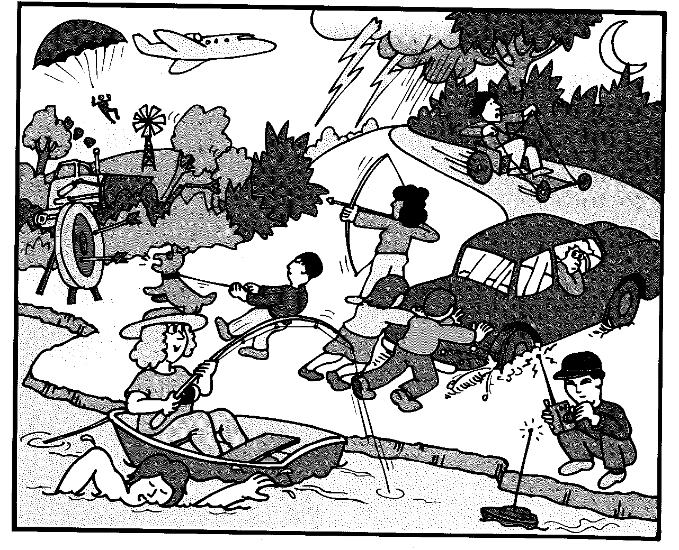
- Circle in the picture an example of a push force (1 mark)
Circle an appropriate picture ( 1mark)
- Put two crosses in the picture where there are examples of a pulling force (2 marks)
Cross an appropriate pictures (2 marks)
2. Match the definition of terms to the words ( i to iii).
(3 marks)
a) gravity ii) | i) a force that is the downward pull of gravity on an object c)
b) mass iii) | ii) a force that pulls two objects with mass together a)
c) weight i) | iii) is the amount of matter in an object b)

3. Johnny put 2 magnets close to each other. Describe what would happen if
a) Two North Poles were facing each other (1 mark)
Repel
b) A North and a South Pole were facing each other (1 mark)
Attract
c) Two South Poles were facing each other (1 mark)
Repel
4. a) List 2 ways that you can reduce friction (2 marks)
any 2 of the following
Lubricant
Rolling
reduce mass
insert air between surfaces or reduce the contact between surfaces
Aerodynamic design to reduce air resistance
b) Name one reason why you would want More friction (1 mark)
Any suitable reason for example. Improving breaks. Studs on soccer shoes to move without slipping
5. True or False (4 marks)
a) If the forces acting on an object are balanced then it is not moving. ___F___
b) Gravity is a contact force ____F_____
c) An object moving at constant speed has an unbalanced force ___F____
d) Magnets only have a repelling force ___F____
6. Determine whether the object forces are balanced or unbalanced by circling one. (4 marks)
a) Balanced / Unbalanced
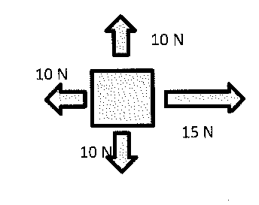
b) Balanced / Unbalanced
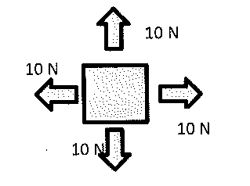
c) Balanced / Unbalanced
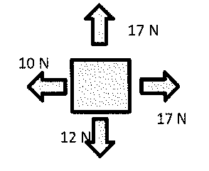
d) Balanced / Unbalanced

